

ADPQ Knowledge Base User Manual



[Publish Date]

Table of Contents

1. Introduction 1

1.1 Logging into the Application 1

2. Content Management 1

2.1 Adding New Articles 2

2.2 Viewing Articles 3

2.3 Searching Articles 3

2.4 Editing Articles 4

2.5 Deleting Articles 4

2.6 Approving Articles 5

2.7 Archiving Articles 5

3. Users Management 5

3.1 Adding New Users 5

3.2 Editing Users 6

3.3 Deleting users 6

3.4 Dashboard 6

1. Introduction

Knowledge Management Tool is a comprehensive collaborative tool that helps to seamlessly share knowledge across cross-functional teams and organizations. Using this tool, employees can share, contribute, organize, and discover information making collaboration easier and more effective. This tool also supports responsive UI (Mobile and Tablet view).

* 1. Logging into the Application

Admin can log into the application using valid credentials to see the landing/home page.

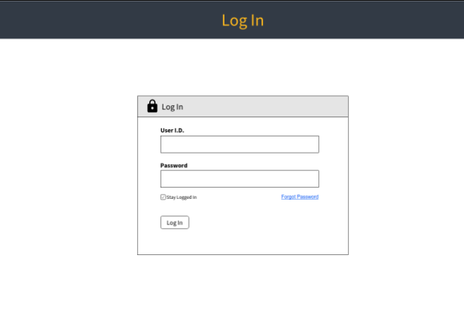

1. Content Management

The landing page displays a list of articles added to the knowledge base. A search box allows the Admin to search for a particular article. The left panel displays a navigational menu.

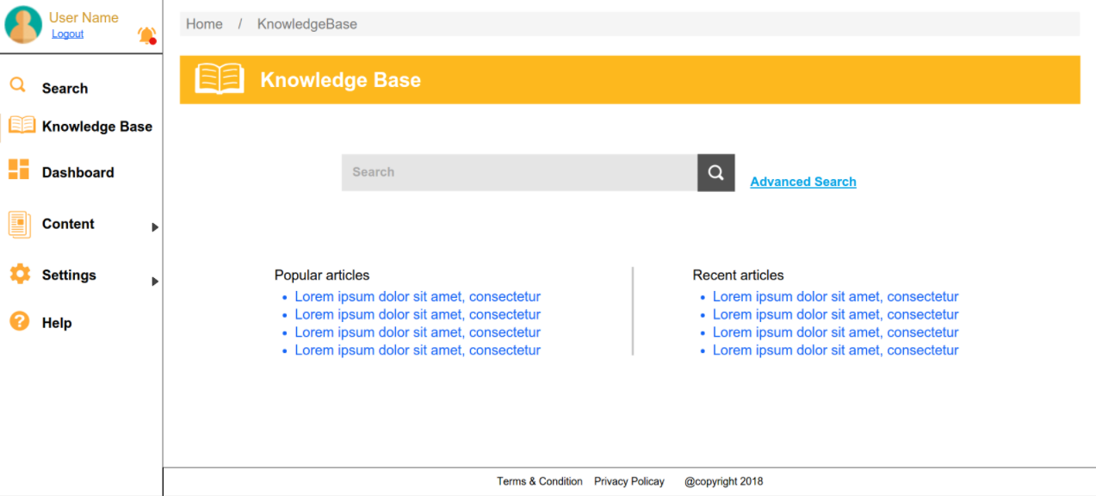

* 1. Adding New Articles

Admin can add articles to the knowledge base with the help of the **Articles** option available on the left menu panel.

To add a new article:

1. Select the **Articles** option from the left menu panel.
2. Click **Add Articles**.

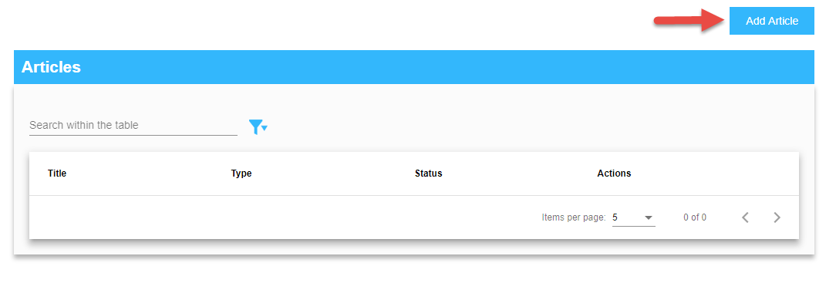

1. In the **Add Articles** page, enter the **Title**, **Description** and select the **Type.** Files can be uploaded using the **Add File** button.

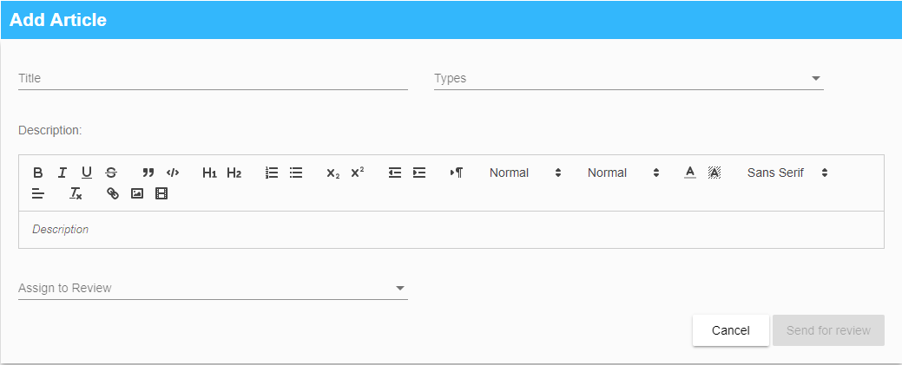

1. From the **Assign to Review** drop-down list, select a reviewer.
2. Click **Send for Review**.
   1. Viewing Articles

Admin can view all the articles including the ones they have created.

To view a new article:

1. Select the **Articles** option from the left menu panel.
2. Click **View Articles**.

To view articles, select the **Articles** option from the left menu panel.

The **Articles** screen consists of four different columns that display the **Title, Type, Status** and **Actions.** A maximum of 50 records can be seen at a time on the page.

To open a specific Knowledge Article, click on any title.

NOTE: Only published articles can be viewed.

* 1. Searching Articles

A search can be done on the Articles page as well as the Knowledge Base page using the **Title, Type or Status** columns. Advanced filtering can also be done using the **Status** and **Role** columns.

<Screenshot>

* 1. Editing Articles

Admin can edit all the articles.

To edit an article:

1. Select the **Article** option from the left menu panel.
2. Click **Edit** from the Edit/Delete option against each article.

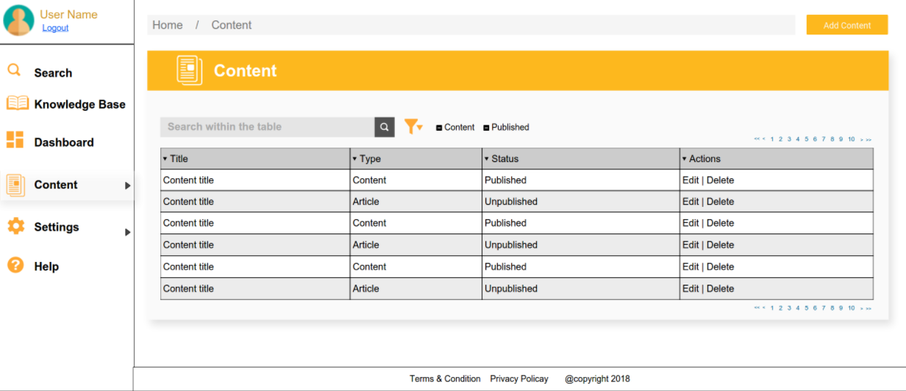

1. Once the appropriate changes have been made, select a reviewer from the **Assign to Review** drop-down list.
2. Click **Send for Review**.

Admin can view the **Last Modified** date and the **Name** of the user who created the article.

NOTE: Published and unpublished articles can be edited.

* 1. Deleting Articles

Admin can delete all the articles.

To delete an article,

1. Select the **Article** option from the left menu panel.
2. Click Delete from the Edit/Delete option against each article.
   1. Approving Articles

Admins can approve all articles.

When an article is sent for review, the Admin/Manager gets a notification to review the article. If the article is not reviewed within 5 days, a notification mail is sent on the 4th day to the user who created the article, requesting to change the reviewer.

To approve an article,

1. Select the **Article** option from the left menu panel
2. From the list of articles, click on the **Assigned to Me** link
3. Click Approve

Once approved, the article is published.

If the Admin/Manager clicks the **Review Comments** button, the comments can be entered in the text box and a reminder is sent to the user who created the article. The status of the article changes to unpublished.

* 1. Archiving Articles

Admin can archive all the articles. Deleted articles are moved to the archive folder and are not searchable.

To archive an article,

1. Users Management

<Content>

* 1. Adding New Users

New users can be added only by an Admin.

To add new users to the knowledge base:

1. Hover on the **Settings** option on the left menu panel.
2. Click **User** from the drop-down.
3. From the **User Settings** screen, click **Add User**.

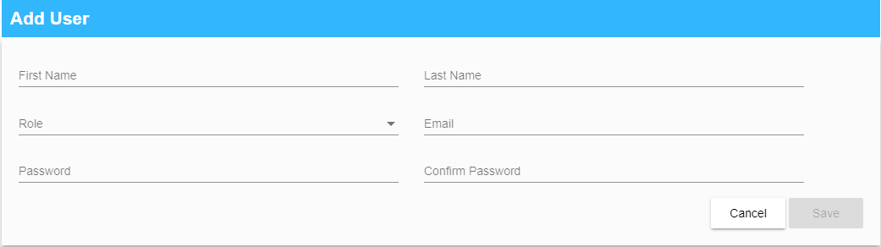

1. Enter the details.
2. Click **Save.**
   1. Editing Users

Users can be edited by Admins and Managers.

To edit users,

1. Navigate to the **User Settings** page
2. Click Edit
   1. Deleting users

Users can be deleted by Admins and Managers.

To delete users,

1. Navigate to the **User Settings** page.
2. Click Delete.
   1. Dashboard

A dashboard can be viewed by Admins.

The Knowledge Base dashboard gives some overall information about the pending content approvals, along with the recently added and recently edited contents. Pending approvals can be approved or rejected from here.

